Café Right Click Options Missing

If the right click options are missing such as “Run this Feature”, “Run Focus..”, and “Run Tests” (figure 1, and figure 2) locate the CafeRegistries.reg file, typically found in c:\cafesetup folder, and double click on Yes

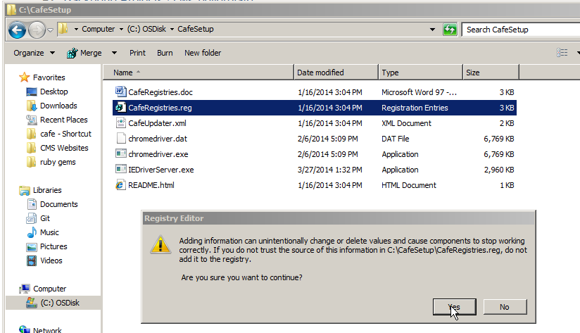

Figure Registering Cafe Entries

If running the CafeRegistries.reg file does not add the right click options, then check the file associations for the feature files.

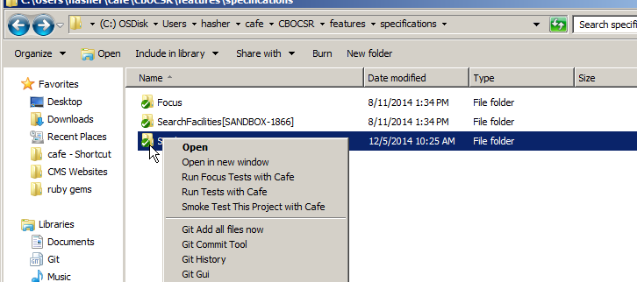

Figure Missing Cafe Right click options

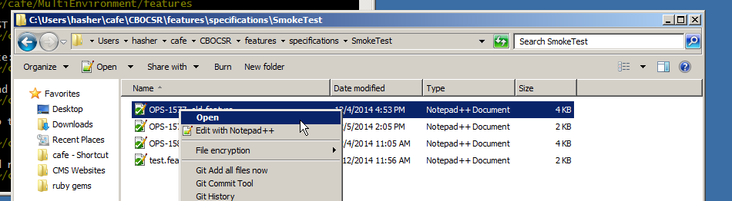

Figure Missing Righ click Options

To register the proper file association, right click on a feature file, select properties, click on Change and select café.bat

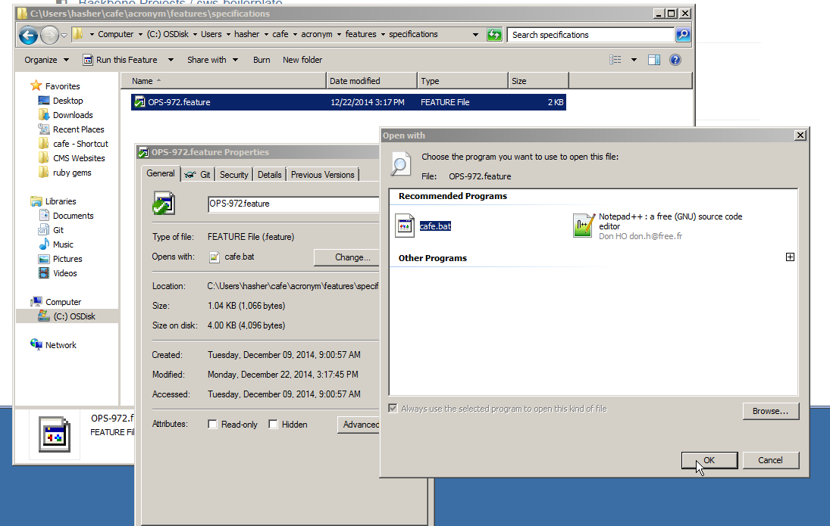

Figure Correcting File Association for Cafe Options

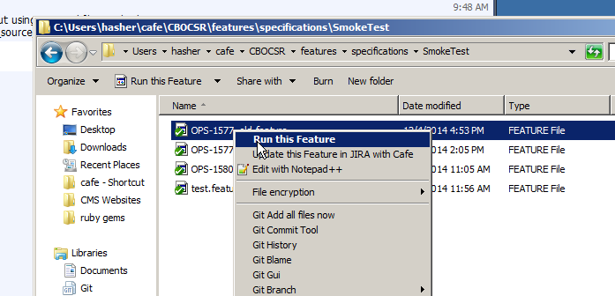

Figure Correct Right Click Options